Open dataset no 1.

The dataset Parks Victoria Campgrounds and Huts (GovHack 2016) is downloaded from <https://discover.data.vic.gov.au/> which is a open data set from the Victorian govt. website. It contains the location data, addresses and other information about various campgrounds in Victoria. The dataset is downloaded as a zip file which contains the shapefile information. This dataset is then wrangled using R and then used for plotting on google maps for the map visualization.

The wrangling (data cleaning) process is explained below:

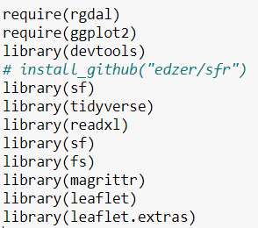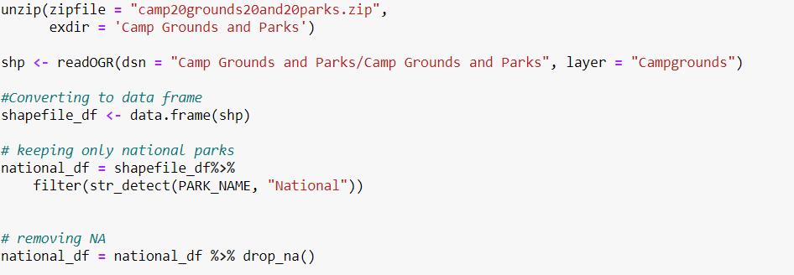

Steps for above:

* After downloading the zip file, unzip it and declare the folder to save the data.
* Use readOGR function to extract the shapefile information
* Convert the shp file to a data frame and filter out only the national parks campgrounds.
* Remove nulls form the data using drop na.

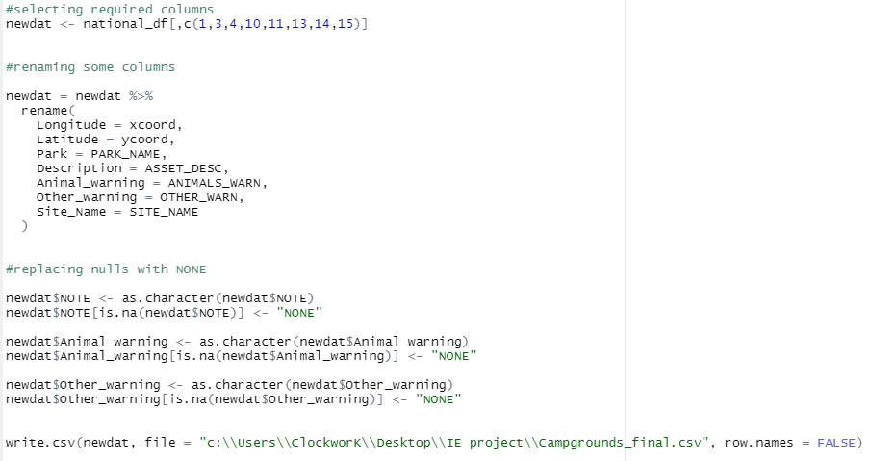

* Keep only the required columns for our purpose.
* Rename a few columns and replace some null fields with ‘NONE’.
* Write the data frame into a CSV which is used in the visualization.

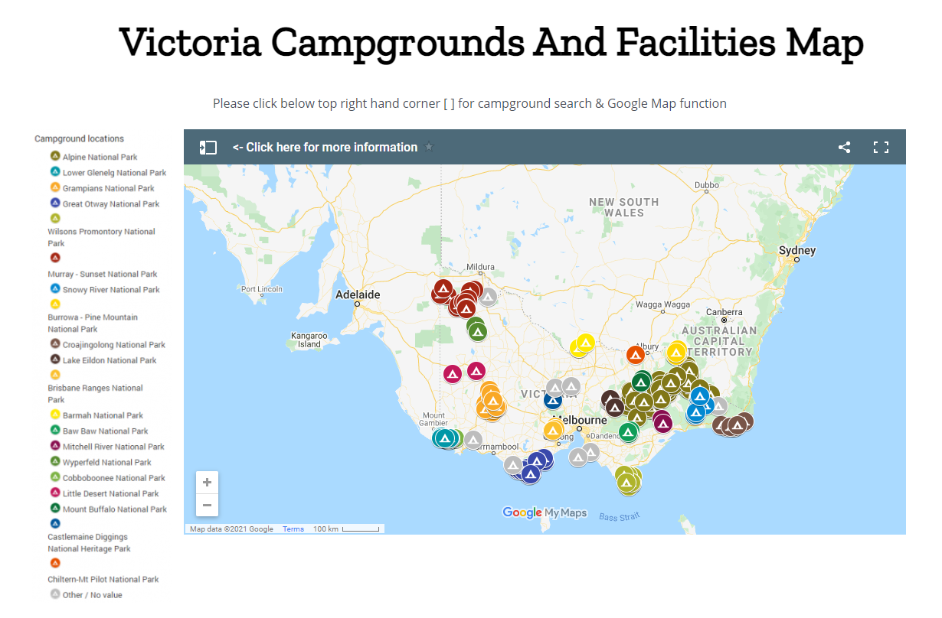

The final csv is used in google MyMaps for the visualization.

Dataset no. 3

This dataset is collected from the Victorian govt. health information website (http://www.health.vic.gov.au/maps/) .It contains the locations of hospitals with in Victoria. The file is downloaded as a kmz file and required wrangling to convert to proper format for visualization purposes.

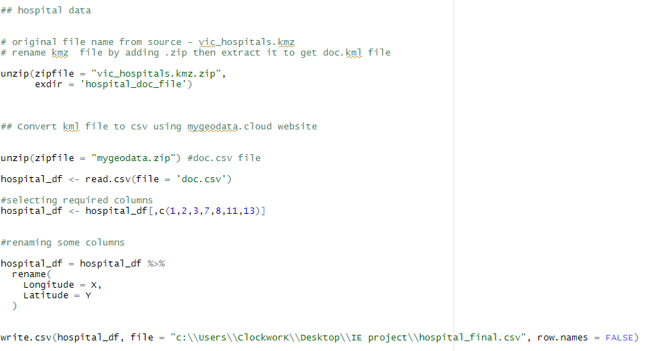

Steps:

* Renaming the kmz file by adding .zip, then extract to get the doc.kml file.
* Convert the kml file to csv format using the mygeodata.cloud website.
* Unzip the file form the website and read it into R using read.csv function.
* Select the required columns and rename the latitude and longitude column names
* Write the data frame into a csv for use in the visualization.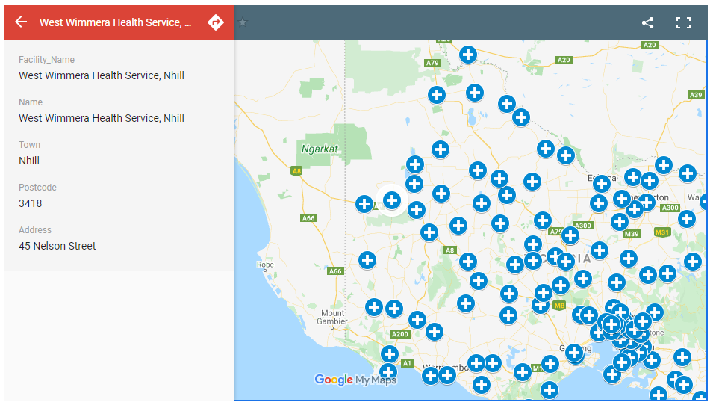

The final hospital file contains location information along with facility names, town name, postcode and address which is displayed in the visualization.

Dataset no. 5

FOI - Index Centroid - Vicmap Features of Interest is downloaded from <https://discover.data.vic.gov.au/> website which is open data from the Victorian government. It contains a dynamic Victorian database of features of interest such as emergency facilities. We extracted the emergency facilities data from here. Same as the other datasets, R was used to clean the data for visualization purposes.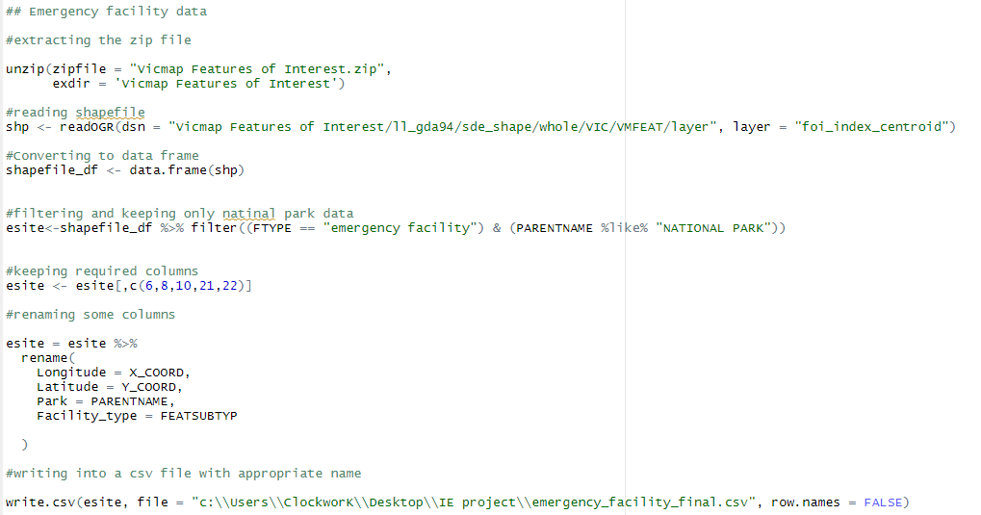

Steps:

* Unzip the Vic map features of interest zip file downloaded from the website.
* Read the shapefile info using readOGR function.
* Convert the shapefile into a data frame and filter out the data where facility type is “emergency facility” and parentname (type of park) is “NATIONAL PARK”.
* Keep the required columns of data and rename some columns for clarity and better understanding of column names.
* Write into a CSV file for the map.

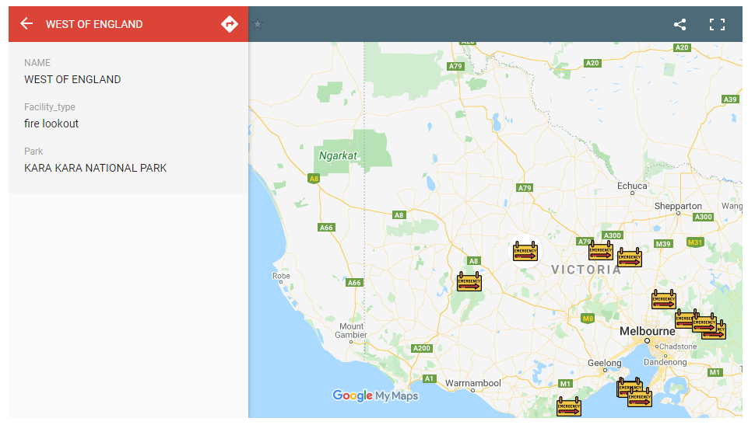

The emergency facilities within Victoria national parks are visualized in the map. The final csv file contains location information as well as name, facility type and name of the park the facility is located.